(Approx. 807 words)

What to Expect in Microsoft Office 2016
By Nancy DeMarte, 1st Vice President, Sarasota Technology User Group, FL
November 2015 issue, Sarasota Technology Monitor
www.thestug.org
ndemarte (at) Verizon.net

Amid all the hype about Windows 10, another Microsoft product has been released: Office 2016. As we all know, Microsoft Office has been the preferred office suite in the business world for many years. Many companies still find that for productivity, a PC, keyboard and mouse are the best option for workers, although tablets are gaining popularity. Office products are not going away.

On July 9, the Mac version of Office 2016 was released to the public. Prices for various versions are predicted to be much the same as Office 2013. The subscription Home Premium version, Office 365, will cost about $100 a year for five installations and $70 a year for the personal, one installation edition. The standalone edition will have a one-time price of $140.
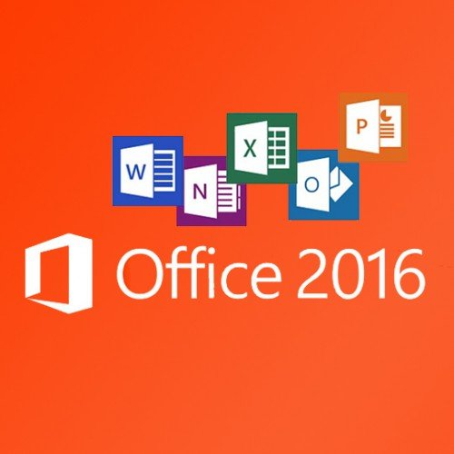
It appears that Office 2016 is being built around a few key goals. It is designed as a cross-platform application that will work well on a computer, tablet or smartphone. It also emphasizes online collaboration and has added some new tools to aid in this goal. In some apps, several people will be able to view and edit the same project simultaneously. Users will be able to see not only who is currently viewing their project, but also who is editing it. All apps in the suite will offer more efficient methods of saving, opening, and editing files in OneDrive. Office 2016 will also include a few new features and several that have been improved. It appears that anyone who has used Office 2007 or later can transition easily to Office 2016. There are no jarringly new tools requiring a long learning curve. It is touted as being a perfect complement to Windows 10, but will work smoothly on Windows 7 or 8.

A few new features are worth a mention. One is the Tell Me bar, which is an updated approach to Help. A user can ask how to perform a task by typing in the bar or verbally asking Cortana, the talking personal assistant, and will be taken to the appropriate spot in the Microsoft support site. Another is Clutter, a feature of the Outlook email program that sorts emails and assigns low priority ones to a special folder for later consideration. Another improvement in Outlook is the option of choosing how much email to download at once onto a phone or small device. Currently, it’s a month’s worth, which can slow down download time. The Insights feature now extends to Excel and PowerPoint instead of just Word and Outlook. If you right click a word or phrase, a sidebar appears containing information related to it from Bing search, Wikipedia, and the Oxford dictionary.

It appears that individual applications in the suite have not changed their basic operation too much, probably to help businesses avoid excessive re-training. But there are predicted to be a few changes. Excel has new analysis capabilities and one click forecasting based on the data on the spreadsheet. It also has some new chart types, such as Waterfall and Tree Map, and keyboard access to Pivot Tables. Outlook lets the user attach links to files in OneDrive. Word and PowerPoint automatically insert photos with the correct orientation and offer more shape styles. One complaint from the bloggers is that PowerPoint, Publisher, and Word have the same sets of templates as they did in Office 2013. There are, however, more themes available. Plus, as I write this, more revisions can still be made.

The new Office will have some formatting changes. Each application will sport a different color, as indicated by its icon and title bar. For instance, Word is blue; Excel is green. (See illustration) The suite color scheme, which has been white, will become somewhat darker to allow easier accessibility for sight-impaired users.

So should you plan to get Office 2016? If you are thinking of using Office on a tablet or phone, using either the Windows, Apple, or Android operating systems, Office 2016 can give you a more touch-friendly experience than previous versions. If a laptop or desktop is still what you prefer to use for productivity jobs, as I do, you might not need to make the change to Office 2016. You may decide to wait for the next Office edition, which, if Microsoft follows its pattern, will be 2019. But if you are still hanging on to Office 2003 or earlier, it is time to upgrade, if for no other reason than much better security. If you do decide to update your Office suite, keep in mind that you can get more features and much better cloud storage if you purchase the subscription (365) version than if you buy the standalone version.

